**Problem Statement**

Create a database named 'custom'.

Create a table named temperature_data inside custom having below fields: 1. date (mm-ddyyyy) format 2. zip code 3. temperature

The table will be loaded from comma-delimited file.

Load the dataset.txt (which is ',' delimited) in the table.

**SOLUTION:**

Database custom is created.

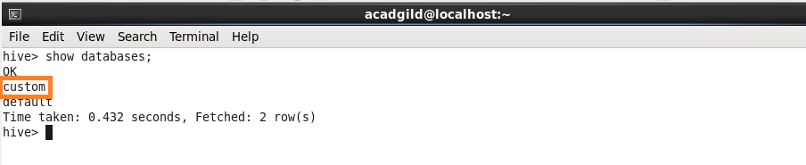

Here custom database is used. Temperature_data table is created and the data is loaded from the local system.

Then a command is used to select all from the table.

